**Mango – Scada 开发**

# Scada2.x

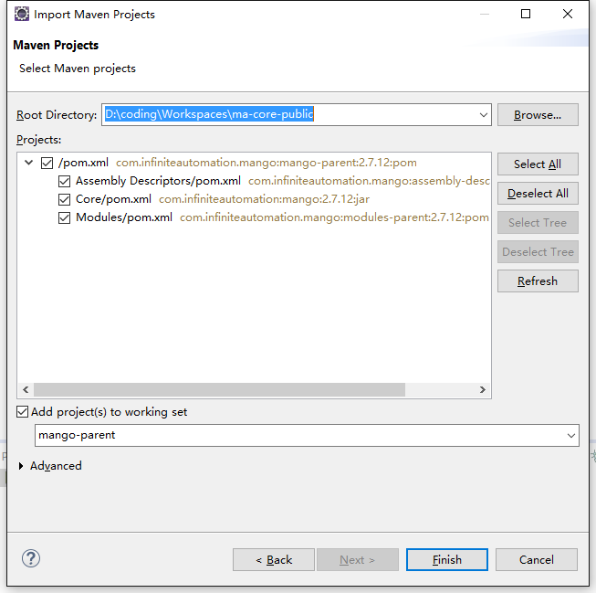

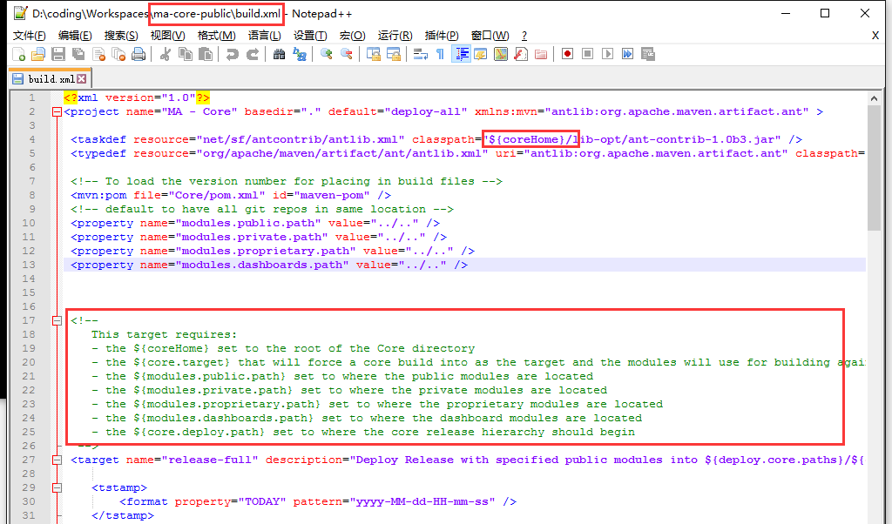

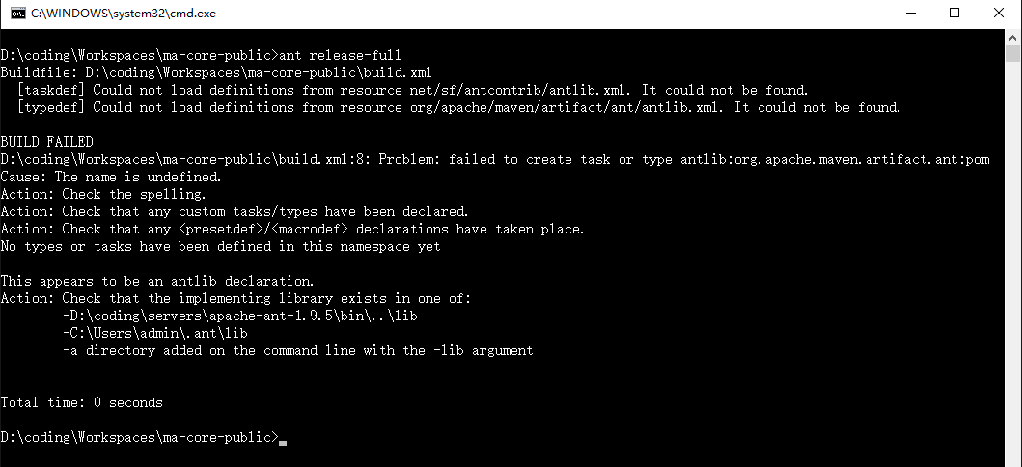

ant -DcoreHome=D:\coding\Workspaces\ma-core-public\Core release-full

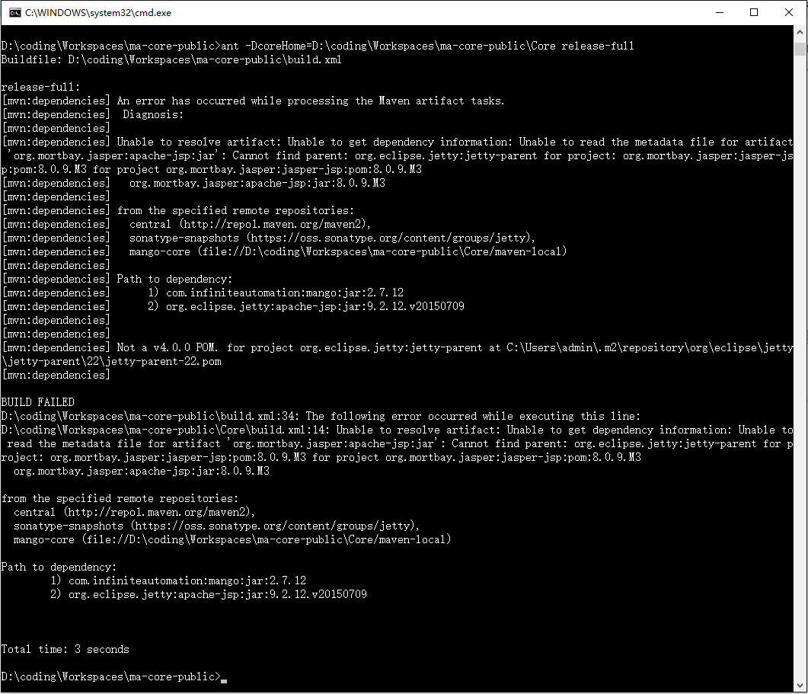

进入core目录执行

ant -DcoreHome=D:\coding\Workspaces\ma-core-public\Core release-full

ant -DcoreHome=D:\coding\Workspaces\ma-core-public\Core compile

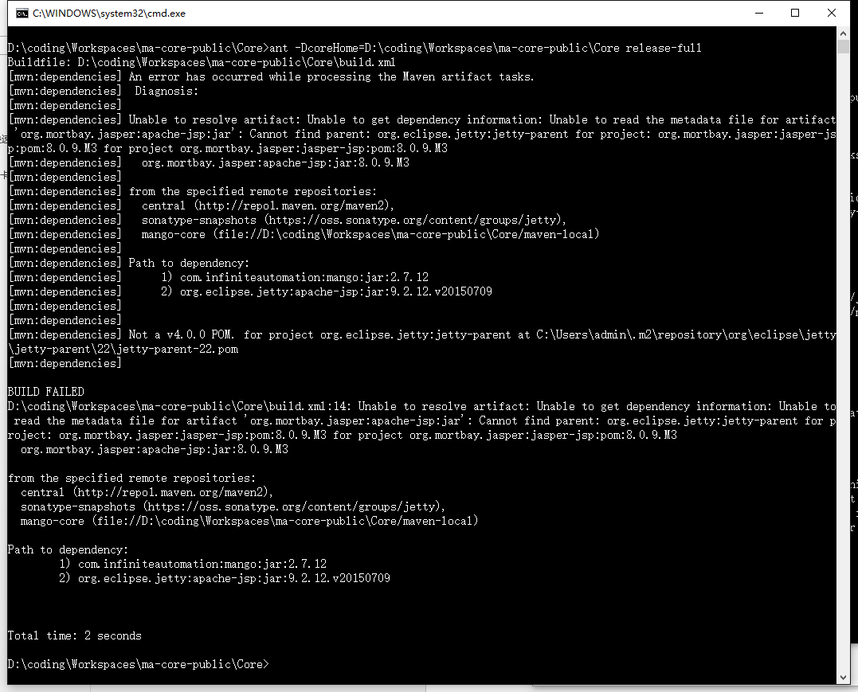

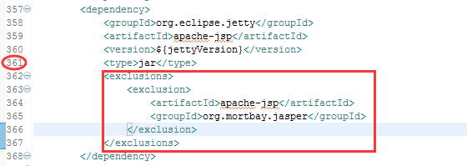

ant -DcoreHome=D:\coding\Workspaces\ma-core-public\Core -Dcore.target=D:\coding\Workspaces\ma-core-public-release release-full

# Scada3.x

源码：<https://github.com/infiniteautomation>

<dependency>

<groupId>com.infiniteautomation.mango</groupId>

<artifactId>ma-priv</artifactId>

<version>3.0.1</version>

</dependency>

**程序运行**

